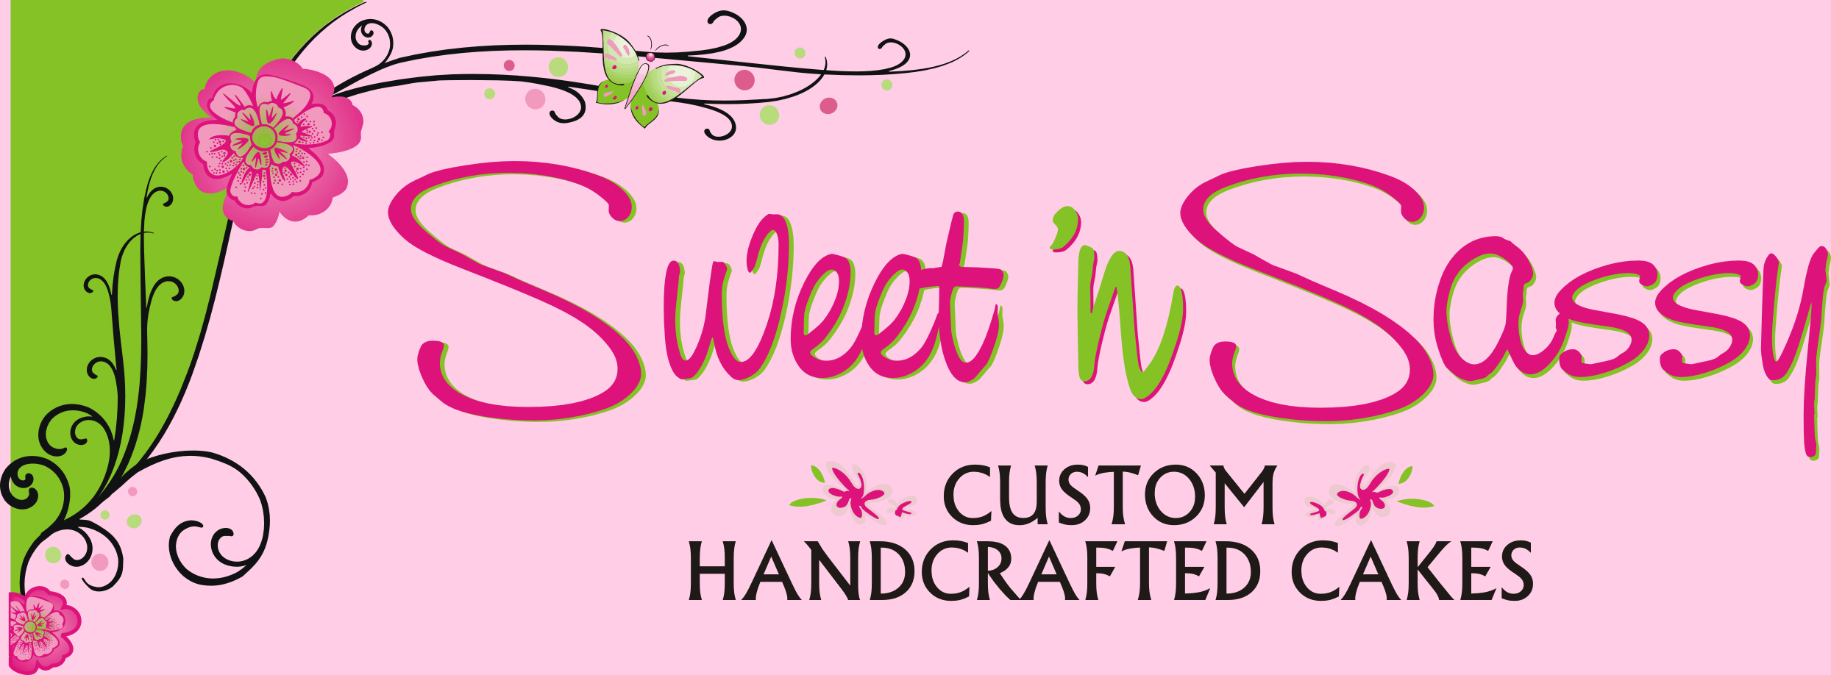 | Bride’s Name:  Date Order Placed:  Retaining Fee Received: $  Remaining Amount Due: $
WEDDING CAKE & GROOMS CAKE CONTRACT
Date of Wedding:
Bride and Groom or Partner:
Address:
Home Phone:
Work/Cell Phone:
Email:
Location of Ceremony:
Ceremony On/Off Site: On-Site Off-Site Time of Ceremony:
Number of Guests:
(This number must be finalized 1 month prior to wedding. Please note, increasing the number of guests may alter the size and price of the cake.)
Name of Reception Hall:
Specific Location:
Specify number of stairs and distance from parking area, as well as any obstacles:

Time of Reception: Delivery Time:
Reception Hall Address:
Reception Hall Phone: Contact Name:
Flowers to be provided by bride/florist: Bride Florist Other:
Florist:
Name:
Phone:
Photographer? Yes No
Company:
Name:
Phone:
 | Bride’s Name:
CAKE DETAILS
Cake Table: Front Display Center of Room
Cake sizes: Cupcakes Total Servings: Y Serve top
N tier?

Cake Style: Round Square Other
(If a special pan shape must be purchased, you will be responsible for 25%)
Stacked Tiered

If tiered and not stacked, stand type:
Non-Refundable Rental Fee: $ Additional Stand Deposit: $
Stands must be returned within three (3) days of event, in good condition. If individual stand components cannot be replaced, missing/damaged parts will result in NO REFUND of deposit.

Type of Cake Topper:

Border? Y N Type:

Cake Flavor: Deluxe? Y N
Filling: Which tiers?

Cake Flavor: Deluxe? Y N
Filling: Which tiers?
More than two flavors will cost an additional $25 : $
Cake Flavor: Deluxe? Y N
Filling: Which tiers?

Buttercream Flavor:

Fondant? (Additional $1.00 per slice) Y N

Additional charges for intricate details and hand made components on cake: $

Additional Cake Details:

 | Bride’s Name:
Pricing Information
The top 6” tier of your wedding cake is our gift to you!
(If your top tier is larger than 6”, you will be charged for the difference in servings)

Price: $  $4.00 x servings/cupcakes (Basic flavor without fondant)
$4.50 x servings/cupcakes (Deluxe flavor without fondant)
$5.00 x servings/cupcakes (Basic flavor with fondant)
$5.50 x servings/cupcakes (Deluxe flavor with fondant)

Fillings: $ (Cupcakes excluded) Regular fillings: $ .50 per serving
Fillings w/ real fruit: $1.00 per serving
Ganache/Bavarian filling: $1.50 per serving

Total additional charges from previous page: $
Supplemental ½ Sheet Cakes: x $180.00 each = $ (60 slices per sheet @ $3.00 per person)
Flower placement charge: $

Subtotal: $
Tax (6.5%): $
Delivery Charge: $ Delivery County & State:
Total*: $
* Total will only change if changes are made to the cake order by the customer after the contract is signed
Retaining Fee: $ (50% of total) to reserve date - $75 Non-refundable Deposit
Balance Due: $ 10 days before event

Please make checks payable to: Sweet ‘n Sassy Cakes
Address: 16806 Heather Knolls Place, Hamilton, VA 20158

 | Bride’s Name:
Cancellations

Cancellations must be received at least four (4) weeks prior to the event in order to receive a refund of your retaining fee minus the $75 non-refundable deposit. A cancellation under four (4) weeks will result in an automatic forfeiture of your full retaining fee to us.

Use of Photographs

We reserve the right to photograph your cake and use our photos or those of your photographer for our own reference or for display/promotional advertising for Sweet ‘n Sassy Cakes without compensation to you.

Liability

We will do our best to make the proper arrangements with you and your reception hall to safely deliver and assemble your cake. Once we have done this, we will not assume responsibility for your guests or caterer’s negligence, property damage or any injury that would occur as a result of our services and provision of your cake.

We appreciate your willingness to follow this contract and its provisions. We must do this to ensure that your wedding experience is truly exquisite and that we all have a clear understanding of your needs and design ideas.

 | Bride’s Name:
FINAL DETAILS
Flowers:
Fresh flowers must be provided by your florist. Please be sure to tell your florist what flowers you want on the cake and how many. If you have a specific design in mind, be sure to relay the information to the florist to assure the same overall look. Be sure to provide us with your florist information so we can work together to ensure the final outcome of your cake is what you ordered.
Flower placement charge on cake at site: $20.00
Flowers given to Sweet ‘n Sassy Cakes 2 hours or more prior to wedding
*Sweet ‘n Sassy Cakes must receive any cake toppers, ribbon and special decorations, a minimum of 48 hours prior to wedding. Please have items ready to use. (i.e.: no cleaning or assembly required).

Private Home Receptions:
Purchaser is responsible to make sure that there is a cake table available at delivery time. Unless specified otherwise, the table must be a minimum of 36 inches in diameter. The table must be secure, level and in a shaded area. The table must be able to support a minimum of 50 pounds. Please restrain any animals that may be on site at delivery time. Once the cake is set up it is no longer the responsibility of Sweet ‘n Sassy Cakes.
Sweet ‘n Sassy Cakes will set up the wedding cake and leave an extra box for the top. The cake box and any other boxes (i.e. cake topper box) will be left for you under the cake table unless otherwise directed.

Changes:
Any major changes must be relayed to Sweet ‘n Sassy Cakes as soon as possible. These include: date, location of reception, time of delivery and florist. Due to scheduling, delivery time changes after booking may not be able to be accommodated.

Finalizing your order:
You must contact Sweet ‘n Sassy Cakes no later than 10 days prior to wedding date. At that time everything on the contract will be finalized including final payment in cash or check.
All communications will be confirmed by Kortni or Cassie via email or fax. If we do not confirm, we did not receive the order or change.

I understand and accept the terms of this agreement:
Date:
We agree to fulfill the terms of this agreement: Kortni O’Grodnick
Cassie Lauterette

